**WORKAROUND DOC**

**Scenario 1 : Error - 32503:New CIR 20 for UNI AS/KRFN/000768/MB cannot support overlying EVCs with total CIR 250.**

**PO 8312429**

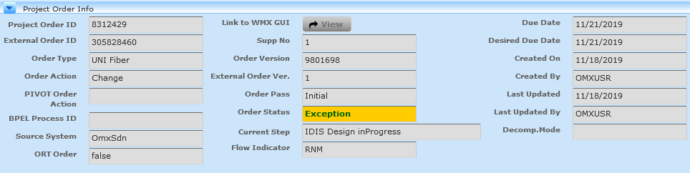

The below exception we are getting for this issue;



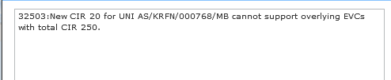

Take the po 8312429 and search in cramer DB for request and response

So its failing at provisioning request , while requesting the CIR =20

Request :

<?xml version="1.0" encoding="UTF-8"?><ns0:uniProvisionRequest xmlns:ns4="http://idis.att.com/rnx/common/v1" xmlns:ns0="http://idis.att.com/rnm/uni/v1" correlationId="2491066987096625910" systemId="CramerInterface" clientId="CramerInterface" requestTime="2019-11-18T06:47:03.414-08:00" idisVersion="1911"><ns4:projectOrderId>8312429</ns4:projectOrderId><ns4:asrOrderNumber>8312429</ns4:asrOrderNumber><ns4:serviceName>AS/KRFN/000768/MB</ns4:serviceName><ns4:action>CHANGE</ns4:action><ns4:isORTOrder>false</ns4:isORTOrder><ns4:isComplexMacdOrder>false</ns4:isComplexMacdOrder><ns0:uniOrderType>NORMAL</ns0:uniOrderType><ns0:isPONR>false</ns0:isPONR><ns0:uniData><ns4:name>AS/KRFN/000768/MB</ns4:name><ns4:type>Fiber</ns4:type><ns4:productType>SDN-ETHERNET</ns4:productType><ns4:customerData><ns4:name>The Island House</ns4:name><ns4:ban>8310007314542</ns4:ban><ns4:contactId>Rynberg, Andy</ns4:contactId><ns4:phoneNumber>9068470088</ns4:phoneNumber><ns4:altContactId>Sehoyan, Alan</ns4:altContactId><ns4:origContactId>OMXUSR</ns4:origContactId><ns4:origPhoneNumber>9999999999</ns4:origPhoneNumber><ns4:businessArrangement>RETAIL</ns4:businessArrangement><ns4:billingPhoneNumber>8310007314</ns4:billingPhoneNumber><ns4:cusId>542</ns4:cusId><ns4:address><ns4:streetAddress1>7308 Main St</ns4:streetAddress1><ns4:city>Mackinac Island</ns4:city><ns4:state>MI</ns4:state><ns4:zipCode>49757</ns4:zipCode><ns4:glid>000102R5DD</ns4:glid></ns4:address></ns4:customerData><ns0:circuitId>AS/KRFN/000768/MB</ns0:circuitId><ns0:portType>1 GIG</ns0:portType><ns0:portHandOff>10/100/1000 Base T</ns0:portHandOff><ns0:portConfig>PORT</ns0:portConfig><ns0:uniIndicator>Fiber</ns0:uniIndicator><ns0:uniType>Fiber</ns0:uniType><ns0:cir>20</ns0:cir><ns0:operationalMode>N/A</ns0:operationalMode><ns0:specCode>OEMAR1</ns0:specCode><ns0:ncCode>KRBD</ns0:ncCode><ns0:switchNCICCode>02CXF.1GE</ns0:switchNCICCode><ns0:nciCode>08LN9.1GE</ns0:nciCode><ns0:powerOptionIndicator>false</ns0:powerOptionIndicator><ns0:secondaryNCI>02CXF.1GE</ns0:secondaryNCI><ns0:macLimit>250</ns0:macLimit><ns0:ipagRouterLocation>STIGMIMN0AW</ns0:ipagRouterLocation><ns0:nteLocation>MCISMI220BW</ns0:nteLocation><ns0:swc>MCISMIMN</ns0:swc><ns0:lata>342</ns0:lata><ns0:isMeetpoint>false</ns0:isMeetpoint><ns0:diversityIndicator>NONE</ns0:diversityIndicator><ns0:isUNIComplex>Yes</ns0:isUNIComplex><ns0:egressProfile><ns0:category>SGOS</ns0:category><ns0:package>Realtime</ns0:package></ns0:egressProfile><ns0:actlApot>MCISMI220BW</ns0:actlApot><ns0:projectName>IDISSDNDISPATCHN</ns0:projectName><ns0:enhancedMulticastIndicator>false</ns0:enhancedMulticastIndicator><ns0:isCnlActivationRequired>false</ns0:isCnlActivationRequired><ns0:criticalDates><ns4:recordIssueDate>2019-11-18-08:00</ns4:recordIssueDate><ns4:appDate>2019-11-18-08:00</ns4:appDate><ns4:schedIssueDate>2019-11-18-08:00</ns4:schedIssueDate><ns4:planTestDate>2019-11-19-08:00</ns4:planTestDate><ns4:commitedDueDate>2019-11-21-08:00</ns4:commitedDueDate></ns0:criticalDates><ns0:additionalNteInfo/><ns0:nlRequestDataList><ns4:tirksData><ns4:facilityType>GE1N</ns4:facilityType><ns4:sysPrefix>JU</ns4:sysPrefix></ns4:tirksData><ns4:nlDataList><ns4:nlData><ns4:aDeviceInfo><ns4:locationName>MCISMI220BW</ns4:locationName></ns4:aDeviceInfo><ns4:zDeviceInfo><ns4:locationName>STIGMIMN0AW</ns4:locationName></ns4:zDeviceInfo></ns4:nlData></ns4:nlDataList></ns0:nlRequestDataList></ns0:uniData></ns0:uniProvisionRequest>

Response :

<?xml version="1.0" encoding="UTF-8"?><uniInvInfoResponse xmlns="http://idis.att.com/rnm/uni/v1" xmlns:ns2="http://idis.att.com/rnx/common/v1" correlationId="2491066987096625910" responseTime="2019-11-18T06:47:14.643-08:00"><ns2:returnInfo><ns2:status>FAILURE</ns2:status><ns2:errorCode>32503</ns2:errorCode><ns2:errorText>32503:New CIR 20 for UNI AS/KRFN/000768/MB cannot support overlying EVCs with total CIR 250.</ns2:errorText></ns2:returnInfo></uniInvInfoResponse>

Now check in logs for this failure :

idis_provisioning.log.20191118.gz:2019-11-18 06:47:12,483 INFO [2491066987096625910] com - **** Current context of connection *** : 0

idis_provisioning.log.20191118.gz:2019-11-18 06:47:12,506 INFO [2491066987096625910] com - Existing Uni service name >>DimId=[8] ObjId=[8962280822] TypeId=[1761020040]

idis_provisioning.log.20191118.gz:2019-11-18 06:47:12,565 INFO [2491066987096625910] com - getEVCsCIRfromUNIService() start

idis_provisioning.log.20191118.gz:2019-11-18 06:47:12,575 INFO [2491066987096625910] com - evcCIR...From UNIService...250

2019-11-18 06:47:12,576 INFO [2491066987096625910] com - getEVCsCIRfromUNIService() end

2019-11-18 06:47:12,580 INFO [2491066987096625910] com - IsSupportedCIR:::false

idis_provisioning.log.20191118.gz:2019-11-18 06:47:12,582 INFO [2491066987096625910] com - validation callout result : false

idis_provisioning.log.20191118.gz:2019-11-18 06:47:12,583 INFO [2491066987096625910] com - Rule Engine Validation failed and about to set error...

idis_provisioning.log.20191118.gz:2019-11-18 06:47:12,586 ERROR [2491066987096625910] com - ValidateUNICallout.perform() RuleEngineValidationException

idis_provisioning.log.20191118.gz:2019-11-18 06:47:12,672 INFO [2491066987096625910] com - PLAN ID BEFORE SETTING TO OPS :: 0

idis_provisioning.log.20191118.gz:2019-11-18 06:47:12,682 INFO [2491066987096625910] com - CalloutException during perform operation on callout com.att.canopi.idis.te.uni.nte.callouts.ValidateUNICallout

idis_provisioning.log.20191118.gz:2019-11-18 06:47:12,684 ERROR [2491066987096625910] com –

So, as per the logs , we checked the Bandwidth value for the service:

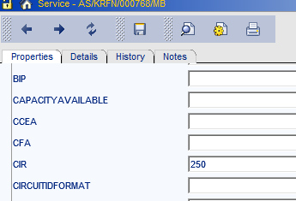

UNI AS/KRFN/000768/MB CIR =250

Overlying EVC - AS/VLXM/000149/MB_AS/KRFN/000768/MB CIR =20

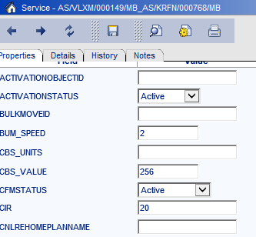

After analyzing this issue , we asked user to disconnect the EVC or downgrade the EVC service and then retry the UNI exception to send the change request . Here , the issue was with user request as both orders were placed at same time .

**Scenario 2**: **Error : Cramer interface did not respond within configured time limit.**

**PO 8318743**

First We analyse the order in canopi , to check where we getting the failure:

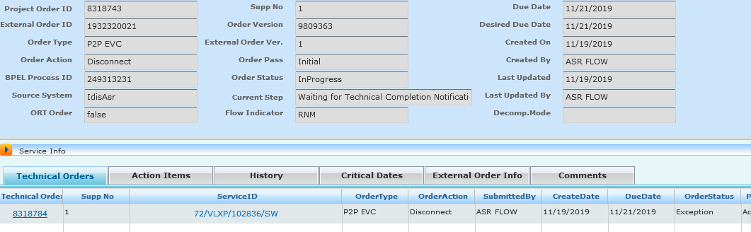

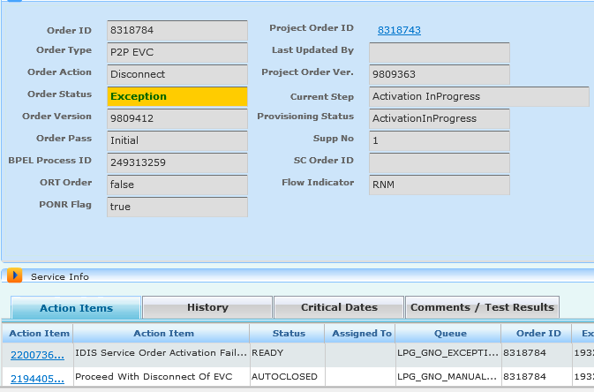

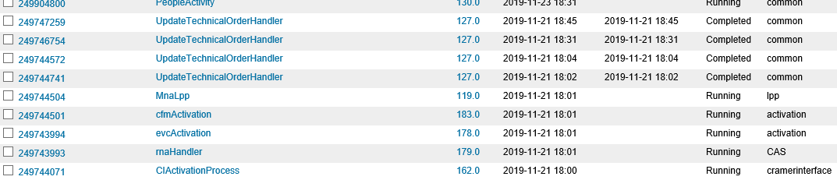

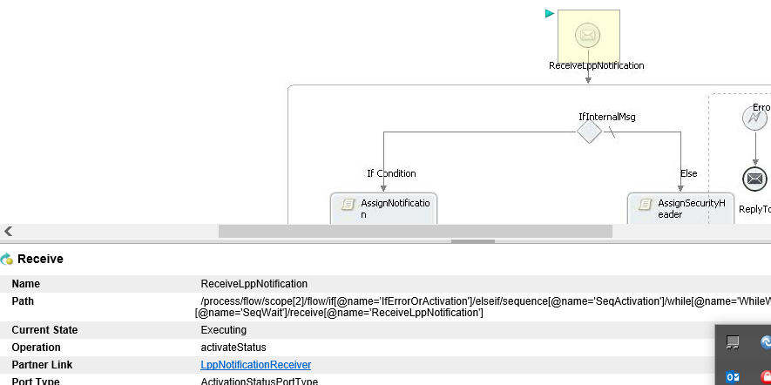

We got below notification from LPP :

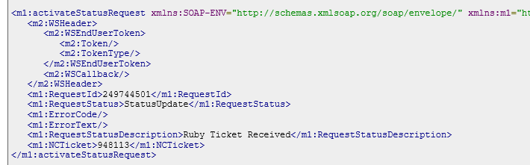

So, the response for activation failed with out any response and Cramer they send timeout response back to Canopi WF.

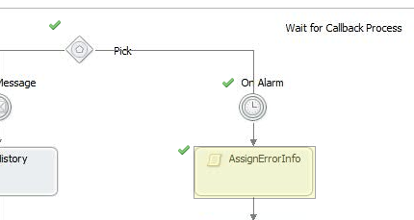

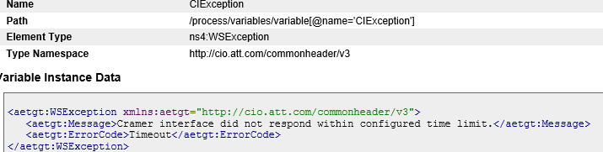

Provision request timeout: <aetgt:WSException xmlns:aetgt="http://cio.att.com/commonheader/v3"><aetgt:Message>Cramer interface did not respond within configured time limit.</aetgt:Message><aetgt:ErrorCode>Timeout</aetgt:ErrorCode></aetgt:WSException>

As after analysis , we have fallout from LPP . So we send the request to LPP with all the details( Order information/ LPP details corrid /RUBY TICKET etc if needed).

Scenario 3 : ERROR: Failed Device: [esm1]

filure info: Network Element Driver error ned_prepare_generic for device esm1:

PO 8321248

We will search the order in canopi .

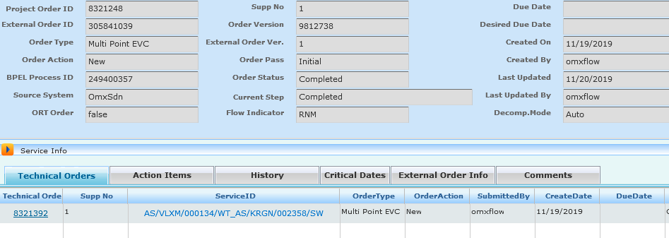

As we move towards the TO ,

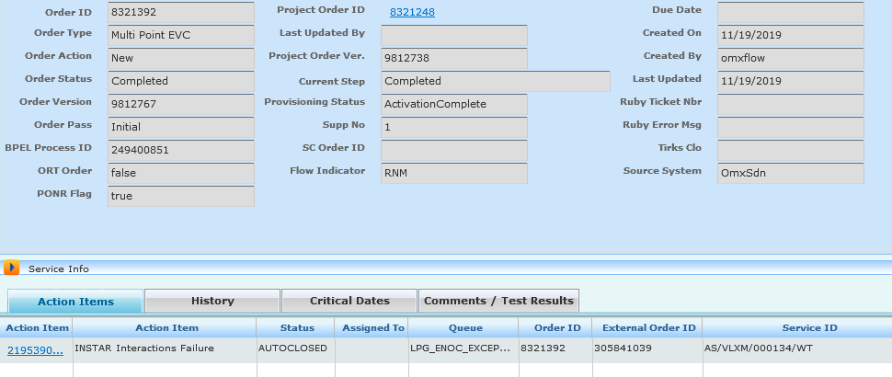

The below was the error :

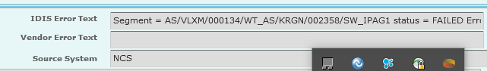

We take the order and check in AVOS , which request its failing

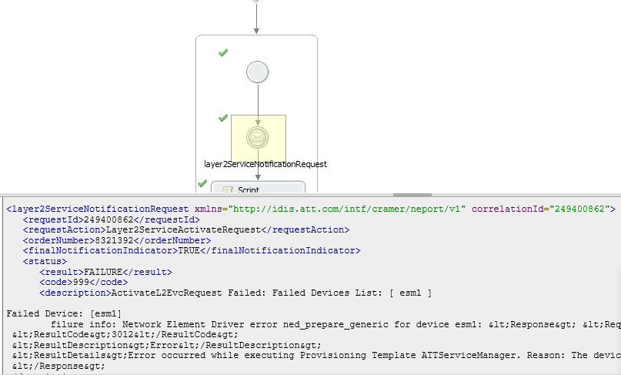

Request in cramer

<?xml version="1.0" encoding="UTF-8"?><ns5:evcActivationRequest xmlns:ns4="http://idis.att.com/rnx/common/v1" xmlns:ns5="http://idis.att.com/rnm/evc/v1" correlationId="2494008528960166522" systemId="CramerInterface" clientId="CramerInterface" requestTime="2019-11-19T16:35:06.547-08:00" idisVersion="1911"><ns5:projectOrderId>8321248</ns5:projectOrderId><ns5:technicalOrderId>8321392</ns5:technicalOrderId><ns5:evcServiceName>AS/VLXM/000134/WT</ns5:evcServiceName><ns5:evcLegServiceName>AS/VLXM/000134/WT_AS/KRGN/002358/SW</ns5:evcLegServiceName><ns5:activityType>activate</ns5:activityType></ns5:evcActivationRequest>

Response:

<?xml version="1.0" encoding="UTF-8"?><ns4:evcActivationResponse xmlns:ns4="http://idis.att.com/rnm/evc/v1" xmlns:ns3="http://idis.att.com/rnx/common/v1" correlationId="2494008528960166522"><ns3:returnInfo><ns3:status>FAILURE</ns3:status><ns3:errorCode>99</ns3:errorCode><ns3:errorText></ns3:errorText></ns3:returnInfo><ns4:data><ns4:externalProjectId>8321392</ns4:externalProjectId><ns4:evcServiceName>AS/VLXM/000134/WT</ns4:evcServiceName><ns4:evcLegServiceName>AS/VLXM/000134/WT_AS/KRGN/002358/SW</ns4:evcLegServiceName><ns4:orderId></ns4:orderId><ns4:evcList><ns4:evcSegment><ns4:segmentName>AS/VLXM/000134/WT_AS/KRGN/002358/SW_IPAG1</ns4:segmentName><ns4:returnInfo><ns3:status>FAILURE</ns3:status><ns3:errorCode>99</ns3:errorCode><ns3:errorText>ActivateL2EvcRequest Failed: Failed Devices List: [ esm1 ]

Failed Device: [esm1]

filure info: Network Element Driver error ned_prepare_generic for device esm1: &lt;Response> &lt;Request>ATTServiceManager&lt;/Request>

&lt;ResultCode>3012&lt;/ResultCode>

&lt;ResultDescription>Error&lt;/ResultDescription>

&lt;ResultDetails>Error occurred while executing Provisioning Template ATTServiceManager. Reason: The device 10.116.39.190 may not be accessible. Please check that the device supports SNMP and is accessible via TCP/IP.&lt;/ResultDetails>

&lt;/Response>

</ns3:errorText></ns4:returnInfo><ns4:evcSegmentGroupList/></ns4:evcSegment></ns4:evcList></ns4:data></ns4:evcActivationResponse>

After analyzing , we getting failure from NCS (downstream )/ENOC . We send mail to the concerned team and ask them to clear the exception along with ENOC team. Once they are done , they will reply back to retry the exception.

**Thank you**

|  |  |
| --- | --- |
|  |  |
|  |  |
|  |  |